Carti Hotel Management System

Use-Case-Realization Specification: View Revenue Report

Version <1.0>

Revision History

| **Date** | **Version** | **Description** | **Author** |
| --- | --- | --- | --- |
| 25/Nov/2024 | 1.0 | Final Version | Hoang Sinh Hung |
|  |  |  |  |
|  |  |  |  |
|  |  |  |  |

Table of Contents

1. Introduction 4

1.1 Purpose 4

1.2 Scope 4

1.3 Definitions, Acronyms, and Abbreviations 4

1.4 References 4

1.5 Overview 4

2. Flow of Events—Design 4

3. Derived Requirements 6

Use-Case-Realization Specification: View Revenue Report

# Introduction

## Purpose

This document describes how the Display Revenue Report use-case is realized within the design model of the Carti Hotel Management System projects.

## Scope

This document applies to the Carti Hotel Management System.

## Definitions, Acronyms, and Abbreviations

None.

## References

None.

## Overview

The subsequent sections comprehensively address the design and associated requirements of the use case. In particular, the flow of events-design part presents the class diagram and sequence diagram, accompanied by concise textual explanations to facilitate understanding.

The subsequent section outlines the derived requirements essential for the implementation of the use case. These requirements serve as crucial guidelines to ensure the successful realization and functionality of the use case.

# Flow of Events—Design

The two diagrams illustrate the essential classes and the sequence of interactions involved in the Report Revenue use case.

Once an admin has successfully logged in, they are directed to the Admin Page. A function is executed, calling the Room Controller to fetch all room numbers along with their availability statuses.

On the Admin Page, the admin can choose the Report option and then select the Revenue Report button. The Revenue Controller handles fetching the revenue data from the database and redirects the admin to the Revenue Report Page.

On the Revenue Report Page, four options are available for displaying revenue reports: daily, weekly, monthly, and yearly. The admin can select the desired report type, and the Revenue Controller will retrieve and display the relevant data.

For the monthly report, the Revenue Controller fetches data for each month, which is then presented on the page.

For the daily, weekly, and yearly reports, an additional step is required where the admin selects a specific day, week, or year. Based on this selection, the Revenue Controller retrieves the corresponding data, which is subsequently displayed on the Revenue Report Page.

## Sequence diagram

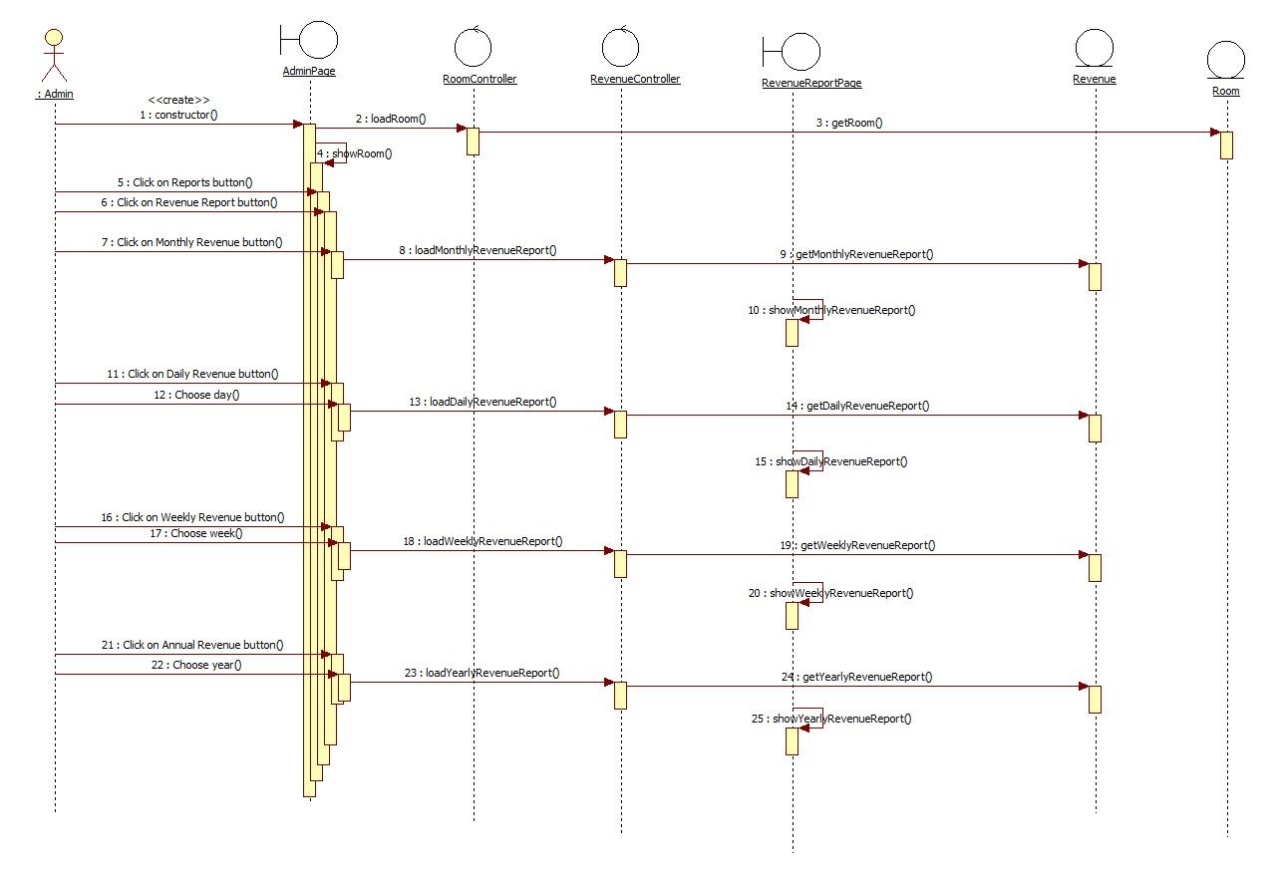

## Class diagram

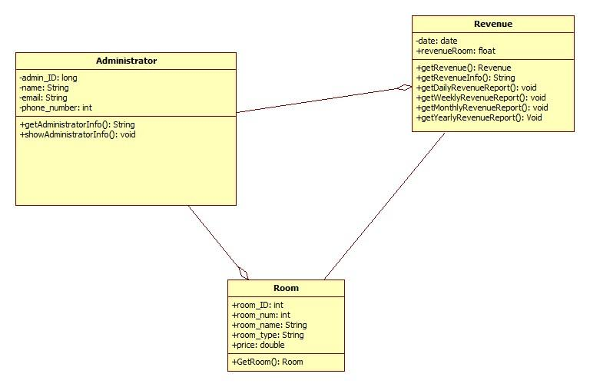

# Derived Requirements

None.